Contact Manager
Ideation Phase
Brainstorm & Idea Prioritization

Date | 17/02/2026
Team ID
Project Name | Contact Manager
Maximum Marks | 4 Marks

Brainstorm & Idea Prioritization
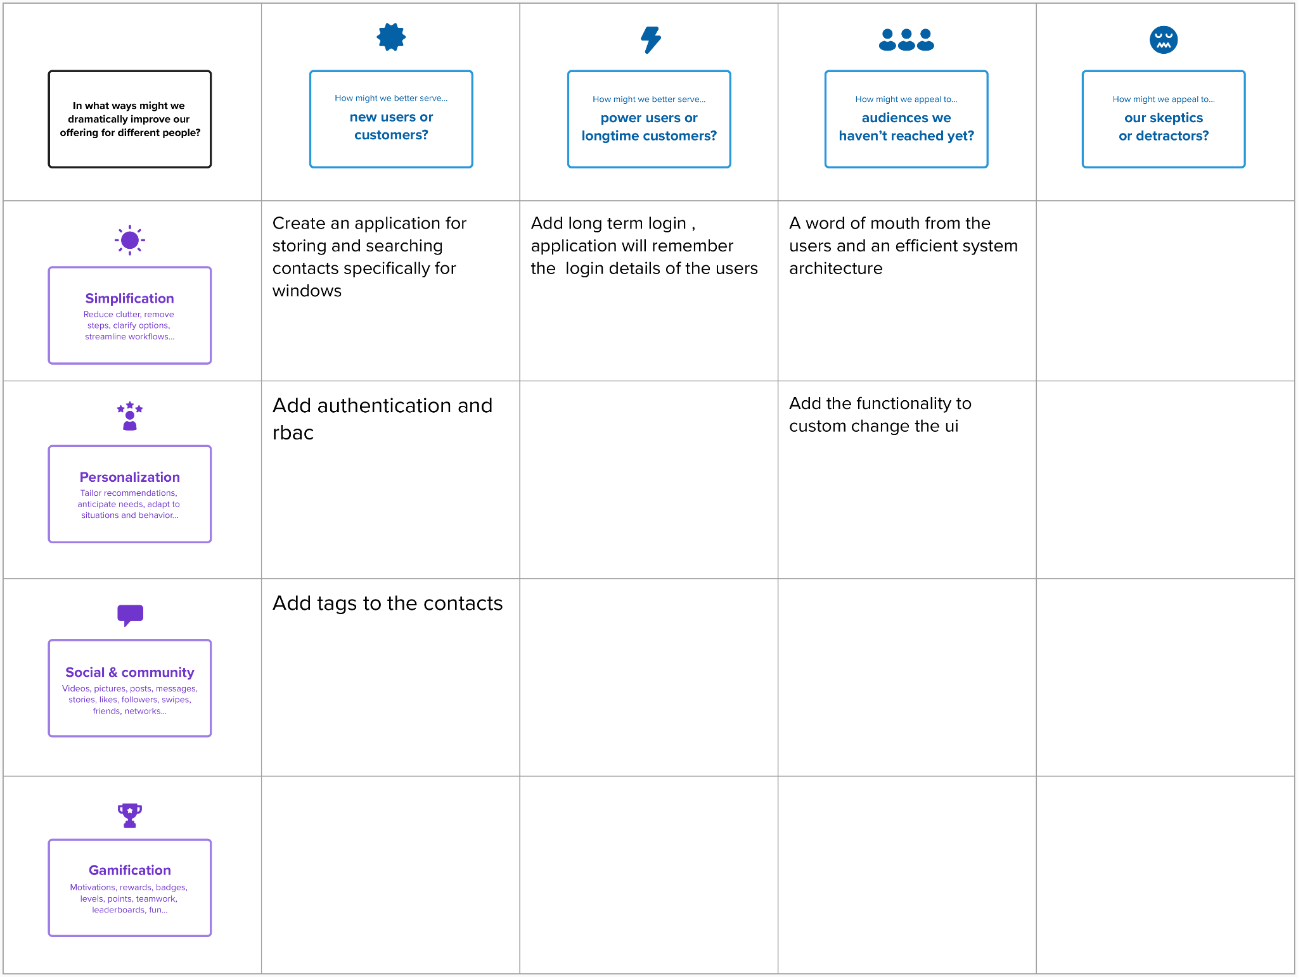

Ste 2 : Idea Prioritization
